

Name: Ajayi Oluwapelumi Joseph
Matriculation Number: AUL/CMP/22/013
Course Code: CMP 419
Course Title: Modelling and Simulation

Write extensively on 5 of the Application Areas of Simulation given to us in our notes.
- Healthcare
- Military
- Manufacturing Industry
- Transportation Modes & Traffic
- Logistics Supply chain & Distribution

Application Areas of Simulation
Simulation is a powerful analytical tool that allows for the creation of a digital or physical model of a real-world system. By experimenting with this model, we can understand the system's behavior, predict outcomes, and optimize its performance without the risks and costs associated with testing in the real world. Below is a detailed exploration of five key application areas of simulation, complete with diagrams and examples.
1. Healthcare
In healthcare, simulation is used to improve patient safety, optimize hospital operations, and enhance medical training. It allows administrators and clinicians to test new protocols, design facility layouts, and practice complex procedures in a risk-free environment.
Key Applications:
- Patient Flow & Capacity Planning: Hospitals use Discrete Event Simulation (DES) to model the path of a patient from admission to discharge. This helps identify bottlenecks, determine the optimal number of beds and staff, and reduce waiting times in critical areas like emergency departments.
- Medical Training: High-fidelity manikins and virtual reality (VR) are used to train medical professionals in everything from basic life support to complex laparoscopic surgeries, allowing them to practice skills and decision-making without risk to real patients.
- Disease Modeling & Epidemiology: System Dynamics (SD) and Agent-Based Simulation (ABS) are used to model the spread of infectious diseases, helping public health officials evaluate the potential impact of interventions like vaccination campaigns or social distancing measures.

Example: Optimizing an Emergency Department
A hospital is experiencing severe overcrowding in its emergency department (ED). By creating a simulation model, they can test different scenarios, such as adding a "fast-track" for less severe cases, increasing the number of triage nurses, or changing the layout of treatment bays. The simulation provides data on key metrics like patient waiting times and resource utilization for each scenario, allowing the hospital to implement the most effective solution.
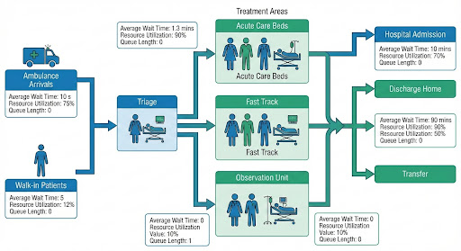
The diagram above illustrates a patient flow simulation for an emergency department. It shows different entry points, a triage process, and various treatment paths. For each stage, the simulation provides critical data such as average wait times and resource utilization, enabling data-driven decisions to improve efficiency.

2. Military
The military is one of the earliest and most extensive adopters of simulation. It is used for training personnel at all levels, from individual soldiers to high-ranking commanders, and for analyzing strategies and testing new weapon systems.

Key Applications:
- Training (Live, Virtual, Constructive): Military simulation is often categorized into three types.
  - Live Simulation: Real people use real equipment in the real world, but with simulated effects (e.g., laser tag for combat training).
  - Virtual Simulation: Real people use simulated equipment in a simulated world (e.g., a pilot in a flight simulator).
  - Constructive Simulation: Simulated people and equipment are controlled by real people in a simulated world (e.g., high-level wargaming for strategic planning).
- Wargaming & Strategic Planning: Commanders use large-scale constructive simulations to test operational plans against various enemy courses of action, identifying potential weaknesses before a real conflict.
- Acquisition & Testing: New vehicles, aircraft, and weapon systems are extensively tested in virtual environments before prototypes are even built, saving billions in development costs.
Example: Joint Military Exercise
Before a large-scale joint military exercise involving army, navy, and air force units, planners will conduct a series of constructive simulations. This allows them to test communication protocols, logistics chains, and tactical plans in a virtual environment, ensuring all branches can operate together effectively before deploying thousands of troops and expensive equipment to the field.
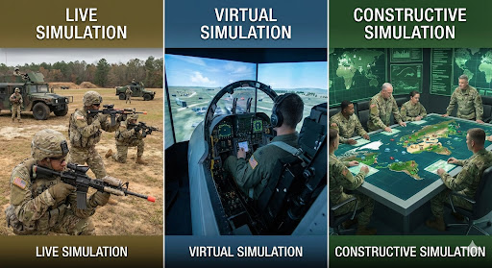
This diagram visually represents the three primary types of military simulation. From left to right: Live Simulation with soldiers in the field, Virtual Simulation with a pilot in a flight simulator, and Constructive Simulation with commanders planning on a digital map.

3. Manufacturing Industry
In manufacturing, simulation is a cornerstone of Industry 4.0, enabling the creation of "Digital Twins" of products, processes, and entire factories. This allows for continuous optimization, predictive maintenance, and agile response to market changes.
Key Applications:
- Digital Twin Technology: A digital twin is a real-time virtual replica of a physical asset or system. By feeding data from sensors on the physical machine to its digital twin, manufacturers can monitor performance, predict failures, and simulate the effect of changes before implementing them on the shop floor.
- Process Optimization: Simulation models of assembly lines and production cells help identify bottlenecks, balance workloads between machines and operators, and determine the most efficient production schedules.
- Facility Layout Planning: Before building a new factory or rearranging an existing one, engineers simulate different layouts to minimize material handling costs, optimize the flow of goods, and ensure adequate space for operations and maintenance.
Example: Automotive Assembly Line Optimization
A car manufacturer wants to introduce a new model on an existing assembly line. They create a simulation of the line to determine the impact on production rate. The simulation reveals that a specific robotic welding station will become a bottleneck. By testing different solutions in the model, they find that adding a second robot to that station is the most cost-effective way to maintain the desired production speed.
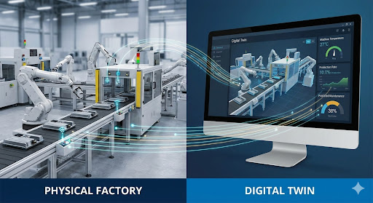
The diagram above illustrates the concept of a manufacturing Digital Twin. Data from sensors on the physical assembly line (left) is streamed in real-time to a virtual replica on a computer screen (right). This allows for monitoring, analysis, and predictive maintenance without disrupting physical operations.

4. Transportation Modes & Traffic
Simulation is essential for planning and managing transportation systems. It helps engineers design better infrastructure, optimize traffic signals, and plan for the integration of new technologies like autonomous vehicles.
Key Applications:
- Traffic Flow Modeling: These simulations can be microscopic (modeling individual vehicles), mesoscopic (modeling platoons of vehicles), or macroscopic (modeling aggregate traffic flow). They are used to analyze congestion, test new road designs, and evaluate the impact of new developments.
- Public Transport Planning: Simulation helps in designing bus and train schedules, determining the optimal number of vehicles, and planning the layout of stations and terminals to handle passenger flow efficiently.
- Autonomous Vehicle Testing: Before self-driving cars can be deployed on public roads, they must undergo billions of miles of testing. Simulation provides a safe and scalable environment to test their algorithms against countless scenarios, including rare and dangerous ones.
Example: Redesigning a Busy Intersection
A city wants to reduce congestion at a major intersection. They create a microscopic simulation model of the current intersection and then test several proposed designs, such as adding a dedicated left-turn lane, changing the traffic light timing, or replacing the intersection with a roundabout. The simulation provides quantitative data on average delays, queue lengths, and vehicle emissions for each option, helping the city choose the best design.
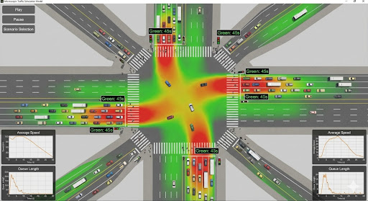
This diagram shows a microscopic traffic simulation of a complex intersection. It models individual vehicles, traffic signals, and pedestrians. A heat map overlay highlights areas of congestion (red) versus free flow (green), and the interface allows for testing different scenarios and analyzing data like average speed and queue length.
5. Logistics, Supply Chain & Distribution
In the complex world of global supply chains, simulation is a vital tool for designing resilient networks, optimizing inventory, and managing risk. It allows companies to test "what-if" scenarios to prepare for disruptions and ensure efficient product delivery.
Key Applications:
- Supply Chain Network Design: Companies use simulation to determine the optimal number and location of suppliers, manufacturing plants, and distribution centers to minimize costs and meet service level agreements.
- Inventory Optimization: By simulating demand variability and supply lead times, companies can determine the optimal inventory levels to hold at different points in the supply chain, balancing the cost of holding inventory against the risk of stockouts.
- Risk Management & Resilience: Simulation is used to model the impact of potential disruptions, such as natural disasters, labor strikes, or port closures. This allows companies to develop robust contingency plans and build more resilient supply chains.
Example: Global Supply Chain Resilience
A global electronics manufacturer uses a simulation model of its entire supply chain to assess its vulnerability to disruptions. They run a "what-if" scenario where a major port in Asia is closed for two weeks due to a typhoon. The simulation shows the cascading effects on production, inventory levels, and customer deliveries worldwide, allowing the company to proactively identify alternative shipping routes and suppliers.
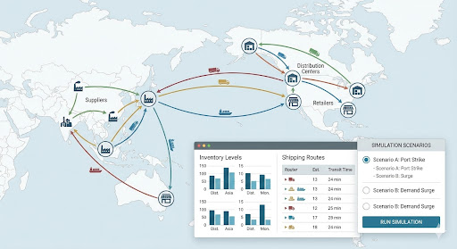
The diagram above illustrates a global supply chain simulation. It maps out suppliers, factories, and distribution centers, showing the flow of goods. The interface allows users to run various "what-if" scenarios, such as a port strike, to see the impact on inventory levels and shipping routes, enabling proactive risk management.

